**Mini Project report submitted to**



**AI Human Emotion Mimicker and Memory Reminder System**

by

**Haiya Shah**

Registration No: 215890018

Department of Computer Science and Engineering

Manipal Institute of Technology

Bengaluru

Under the supervision of

|  |
| --- |
| **Dr. Pavithra N.**  Assistant Professor  Department of Computer Science and Engineering  Manipal Institute of Technology  Bengaluru |

|  |  |
| --- | --- |
|  |  |

**Manipal Institute of Technology**

**Bengaluru Campus-560064, Karnataka, India.**

**Certificate**

This is to certify that as the record of the mini project work carried out by them, is accepted as the Mini Project reportsubmission in partial fulfilment of the requirements for the award of degree of Bachelor of Technology (BTech).

|  |  |
| --- | --- |
| **Examiner Name** | **Signature with the Date** |
| Dr. Pavithra N. | ……………………………… |

**ABSTRACT**

The AI Emotion Mimicker & Memory Reminder System is an innovative project aimed at transforming user interaction with technology through the integration of advanced artificial intelligence (AI) capabilities with a robust full-stack architecture. This comprehensive system encompasses various components, including the frontend, backend, database, API usage, algorithms, and AI integration, meticulously designed to deliver a personalized and immersive user experience.

The existing landscape of emotion mimicking and memory reminder systems lacks depth in human emotion understanding and often provides fragmented solutions for memory storage and reminders. Standalone applications typically focus on either emotion mimicking or memory storage, resulting in disjointed user experiences. To address these limitations, the AI Emotion Mimicker & Memory Reminder System is designed to offer a comprehensive solution that seamlessly integrates AI capabilities with a robust full-stack architecture.

**INDEX**

|  |  |  |
| --- | --- | --- |
| **SL. NO.** | **CONTENTS** | **PAGE NO.** |
| 1 | INTRODUCTION | 1 |
| 2 | PROBLEM STATEMENT | 2 |
| 3 | OBJECTIVES | 3 |
| 4 | METHODOLOGY | 4 |
| 5 | IMPLEMENTATION | 6 |
| 6 | RESULTS | 8 |
| 7 | CONCLUSION | 9 |
| 8 | REFERENCES | 10 |

**INTRODUCTION**

The AI Emotion Mimicker & Memory Reminder System represents an innovative endeavor aimed at revolutionizing user interaction with technology. Through the integration of advanced artificial intelligence (AI) capabilities with a robust full-stack architecture, this project seeks to provide a personalized and immersive user experience.

Comprising various components such as the frontend, backend, database, API usage, algorithms, and AI integration, this comprehensive system has been meticulously designed to cater to the diverse needs of users.

The current landscape of emotion mimicking and memory reminder systems often falls short in understanding human emotions and delivering efficient memory storage solutions. Typically, standalone applications focus solely on one aspect, leading to fragmented and disjointed user experiences.

To overcome these limitations, the AI Emotion Mimicker & Memory Reminder System offers a holistic solution. By seamlessly integrating AI capabilities within a robust full-stack architecture, it aims to provide users with a cohesive and seamless experience, ensuring both emotional understanding and efficient memory management.

**PROBLEM STATEMENT**

This project aims to develop an AI system capable of mimicking human emotions, understanding and replying with emotional support and a real time conversation.

**OBJECTIVES**

The objectives of this project encompass:

1. Emotion Mimicking: Develop an AI capable of accurately mimicking a wide range of human emotions in real-time.
2. Memory Storage: Implement a secure and scalable memory storage system to allow users to store various types of memories including images, videos, and text.
3. Personalized Feelings: Utilize machine learning algorithms to analyze user behavior and preferences, providing personalized feelings for events and tasks.
4. Scalability and Performance: Optimize the system for scalability and performance to accommodate a growing user base and ensure smooth operation

**METHODOLOGY**

The methodology can be classified into seven essential steps:

1. Data Collection: Gather extensive textual data from various sources, including literature, articles, and online content, to create a diverse dataset for emotion analysis and story recommendation.
2. Preprocessing: Utilize natural language processing techniques to preprocess the collected data, including tasks such as tokenization, stop-word removal, and stemming, to prepare the text for further analysis.
3. NLP Processing: Apply NLP techniques, including NTL n-grams, to the preprocessed data to analyze patterns and sentiments associated with different emotional states. Extract features relevant to emotion recognition, such as word context and frequency.
4. Emotion Recognition: Train emotion recognition models using machine learning algorithms on the processed data to accurately identify and categorize emotional states expressed in the text. Evaluate the models' performance and refine as necessary to improve accuracy.
5. Feelings Recommendation: Develop a recommendation system that suggests relevant feelings based on the user's emotional state inferred from the analyzed text. Utilize techniques such as collaborative filtering or content-based filtering to personalize recommendations.
6. Integration: Integrate the emotion recognition and feelings recommendation components into a cohesive AI system, ensuring seamless interaction between the two functionalities.
7. User Interaction: Design a user interface that allows users to input text or interact with the system, receiving personalized emotion mimicking and memory reminder services based on their input.

**IMPLEMENTATION**

Code and Explanation

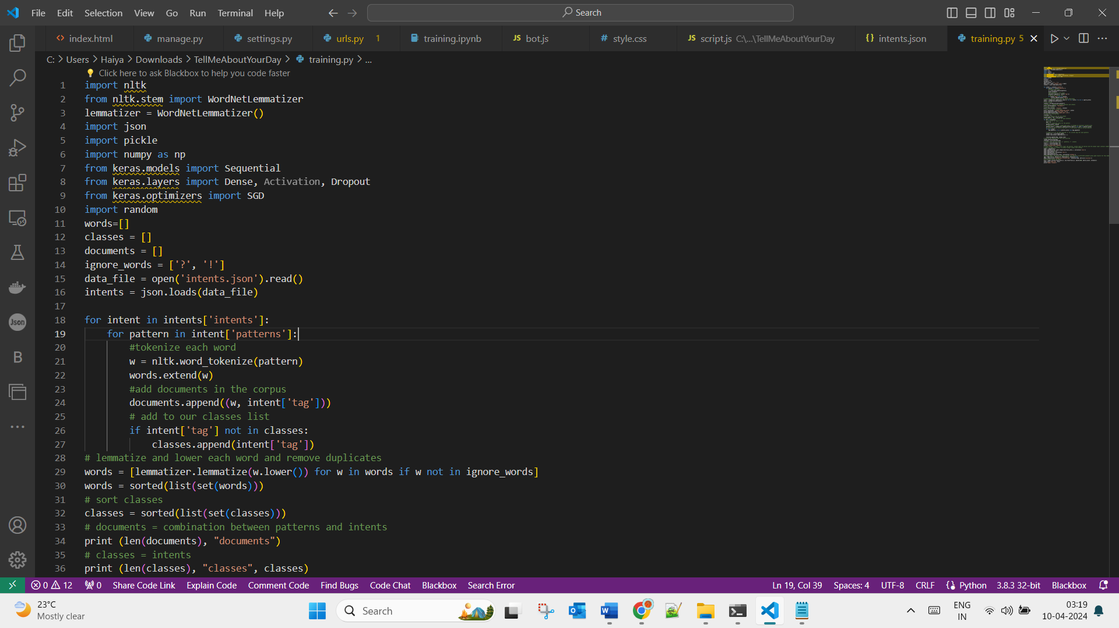

Fig. 1: Natural Language Processing training of the bot on the English language and sentiment analysis training

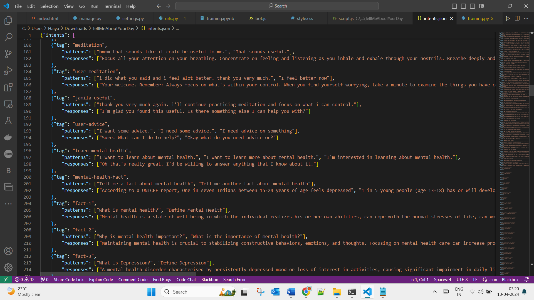

Fig. 2: Training data

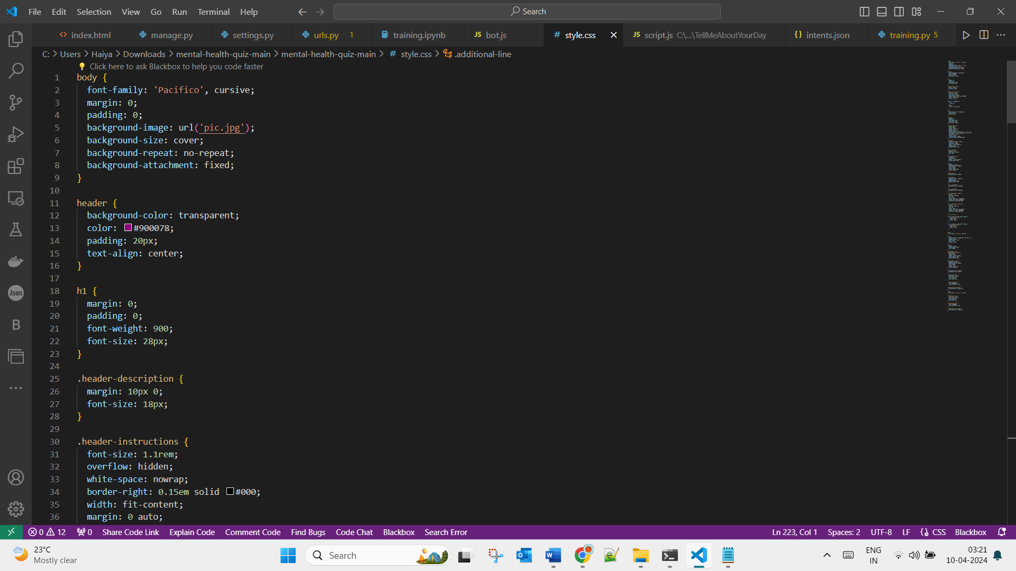

Fig. 3: Snippet of code for style.css

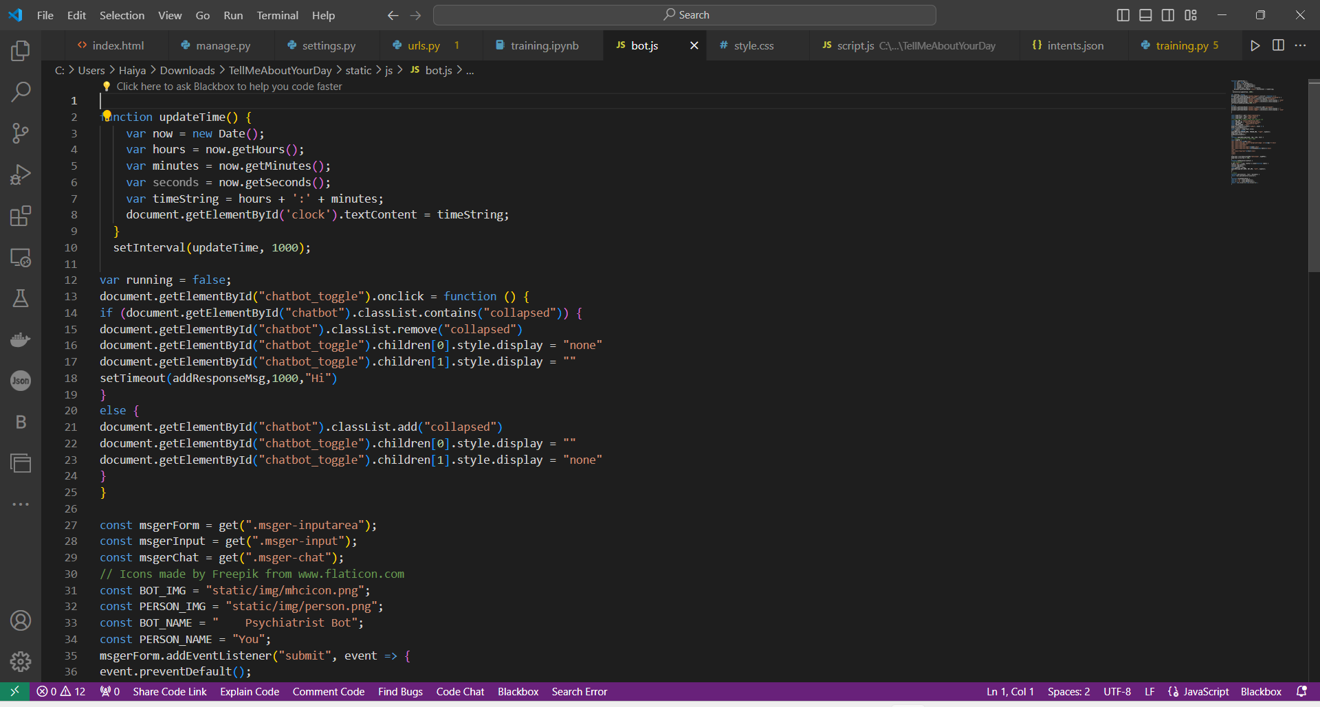

Fig. 4: Snippet of code for bot.js

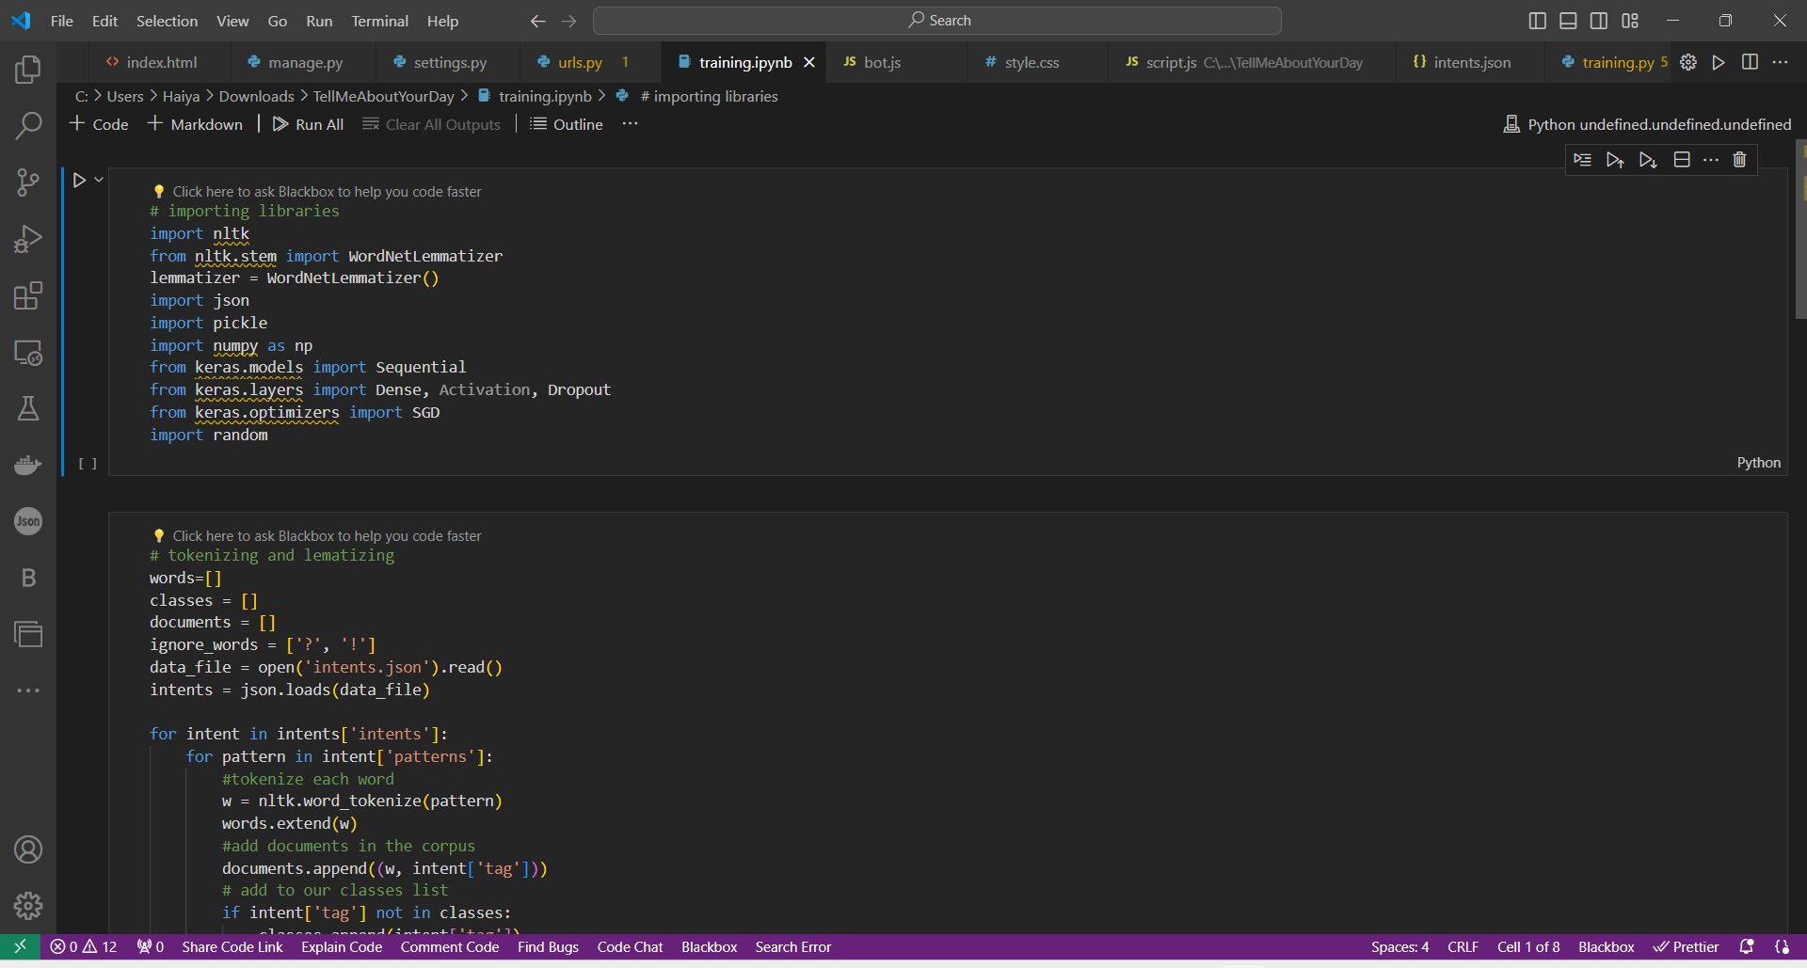

Fig. 5: Snippet of code for Training.ipynb file

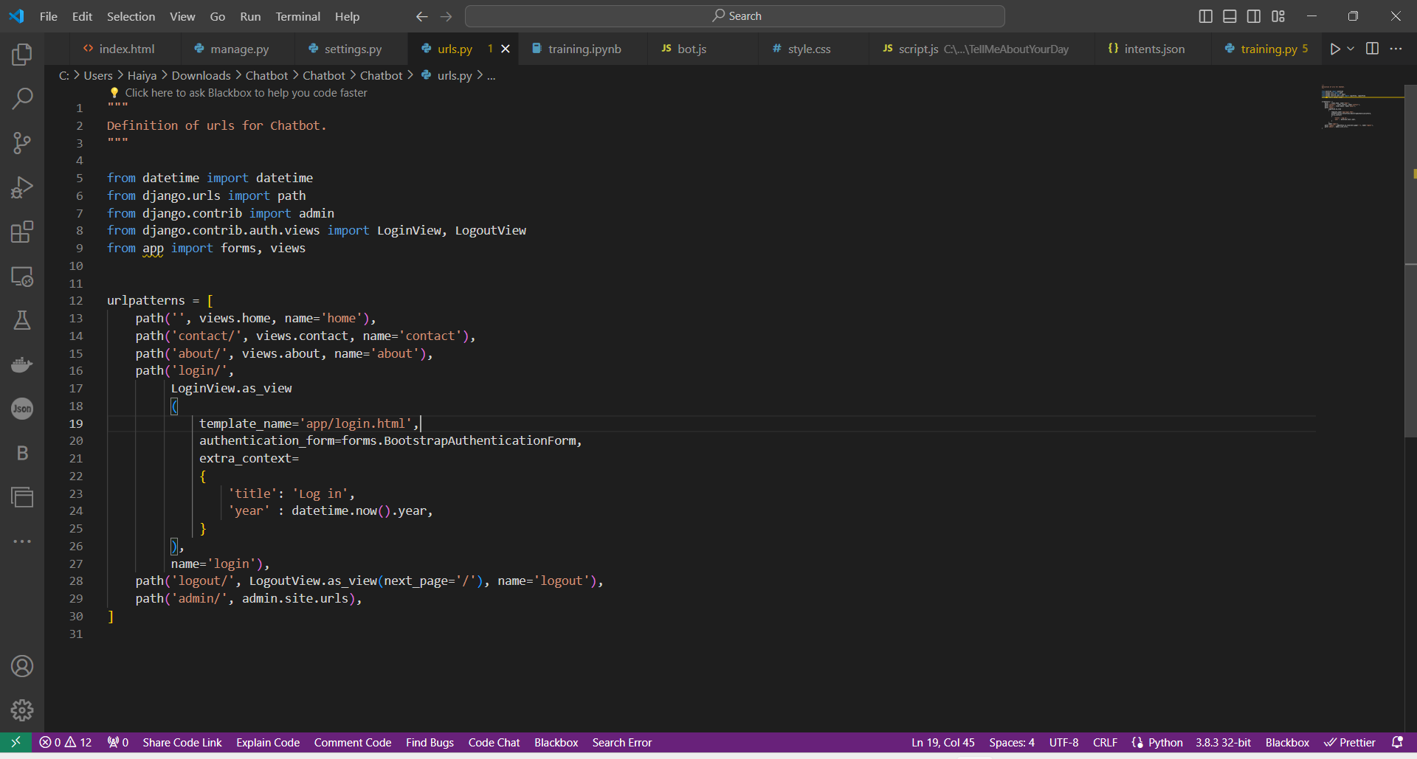

Fig. 6: Snippet of code for urls.py

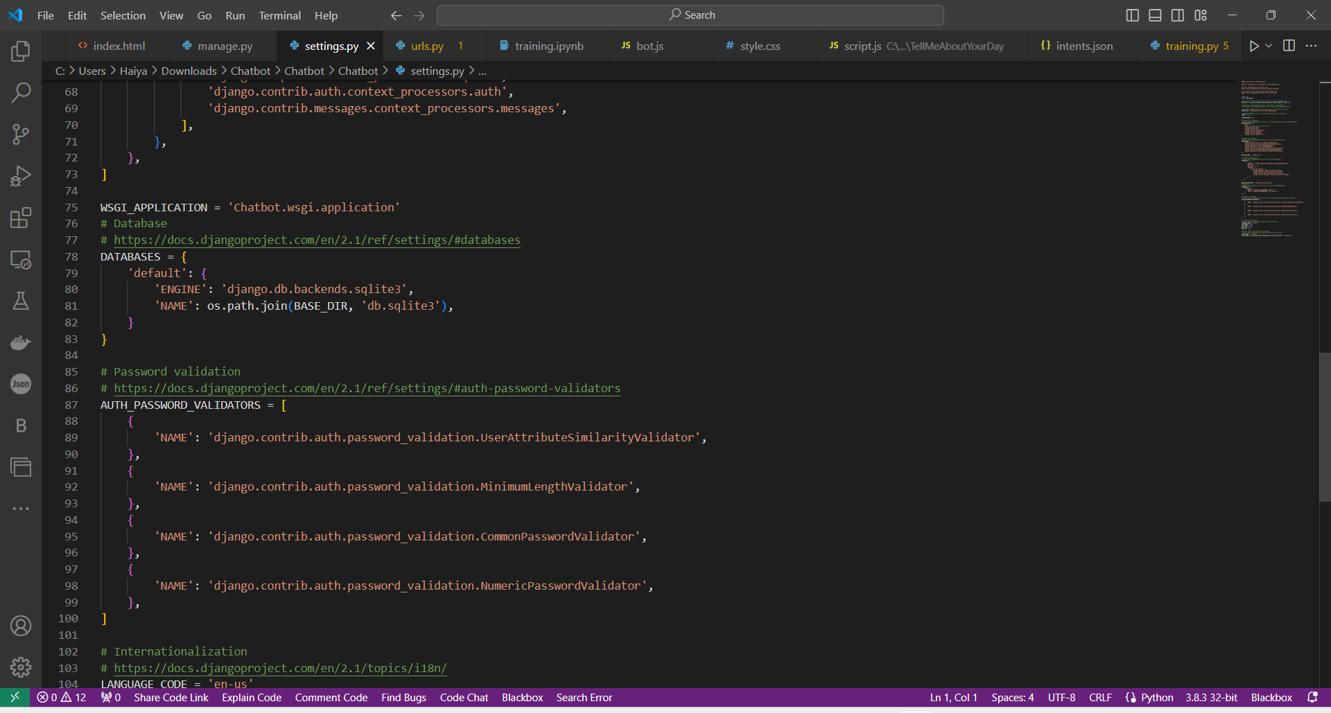

Fig. 7: Snippet of code for settings.py

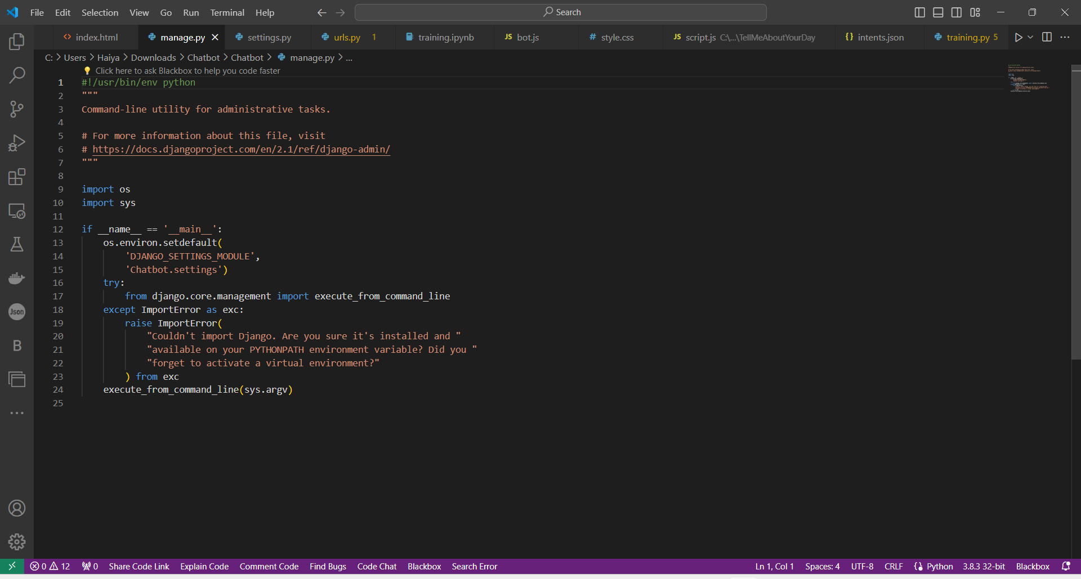

Fig. 8: Manage.py

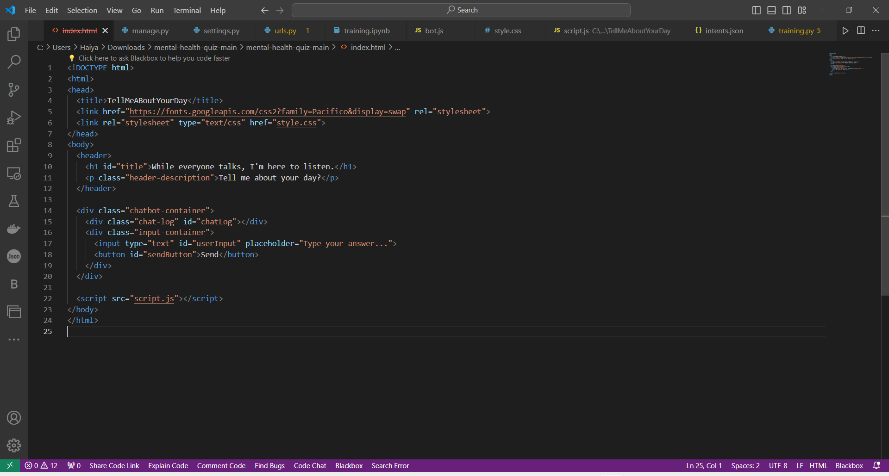

Fig. 9: Index.html

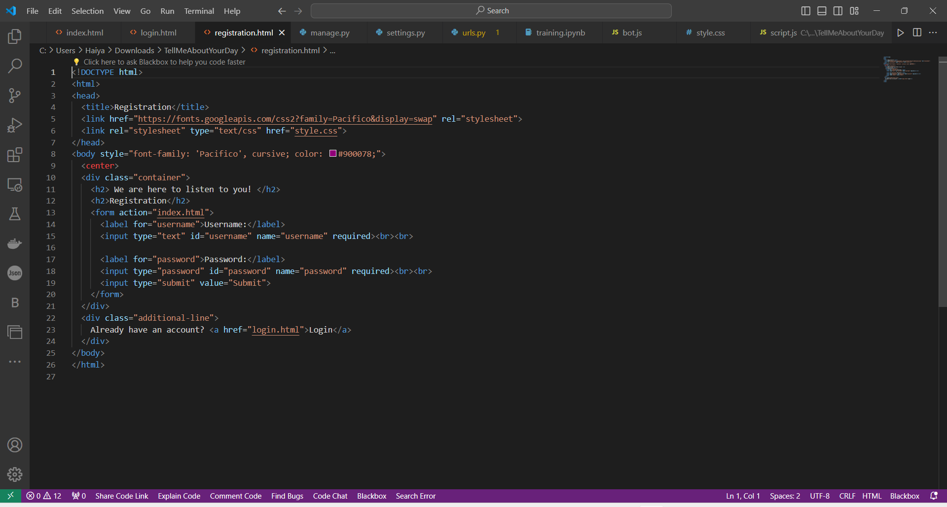

Fig. 10: Registration.html

**RESULTS**

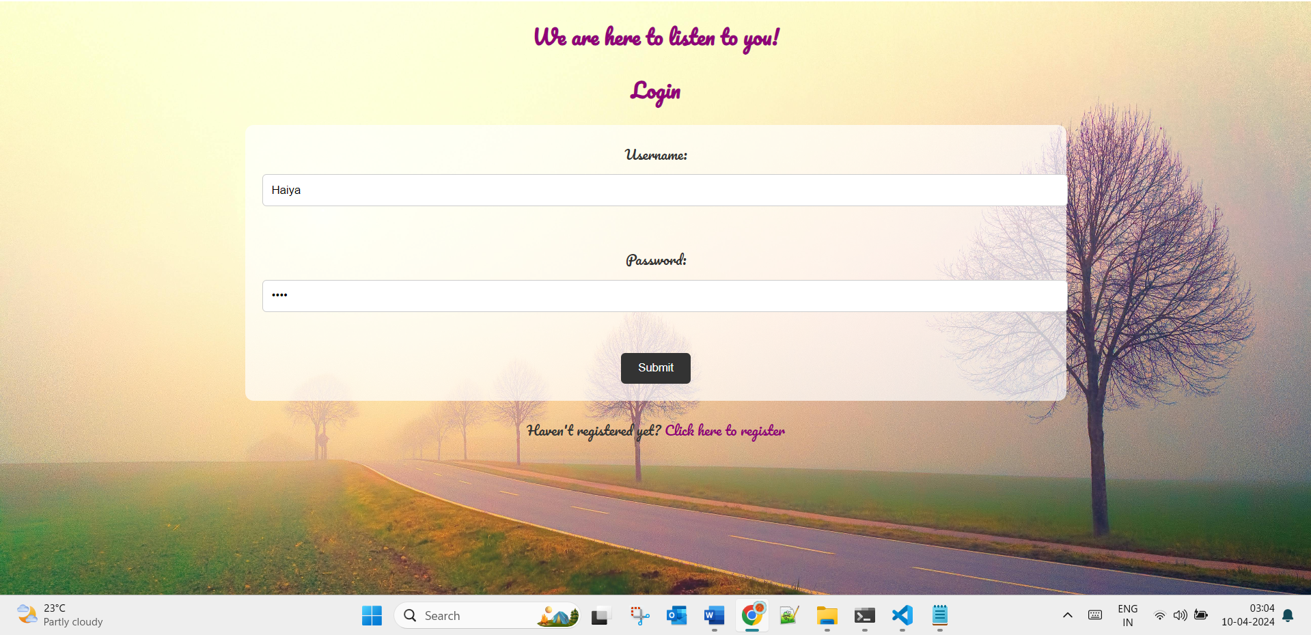

Fig. 11: Login Page

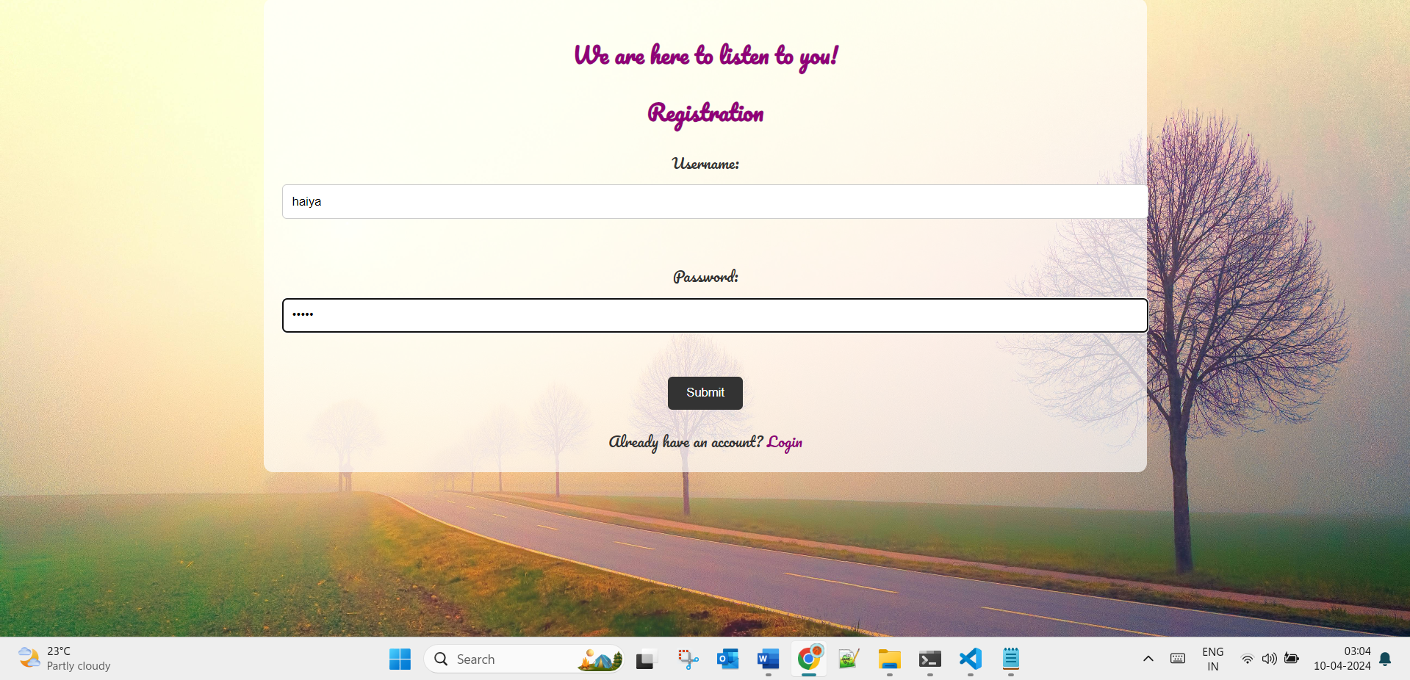

Fig. 12: Registration Page

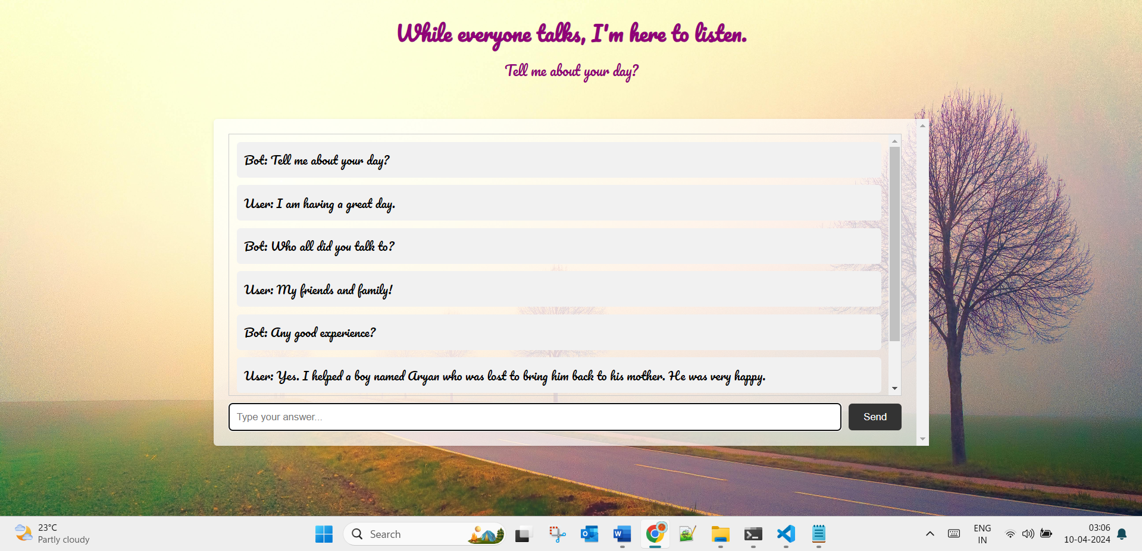

Fig. 13: The conversation

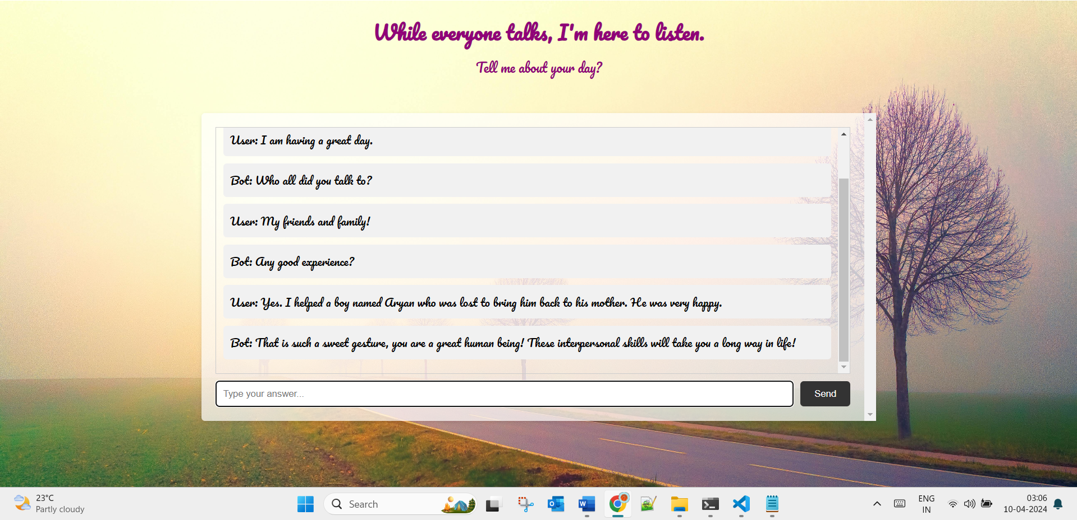

Fig. 14: The conversation continued.

**CONCLUSION**

The AI Emotion Mimicker & Memory Reminder System represents a significant advancement in technology, offering users a unique and personalized experience. By leveraging advanced AI capabilities, robust architecture, and a user-centric design approach, this system redefines the way users interact with technology, enhancing their daily lives and emotional well-being.

**REFERENCES**

1. Django: <https://www.djangoproject.com/>
2. TensorFlow: <https://www.tensorflow.org/>
3. Keras: <https://keras.io/>
4. Natural Language Processing: <https://en.wikipedia.org/wiki/Natural_language_processing>